Homework #5
(Module 5: Substation Automation)

Question 1: Which bus arrangement is the most reliable and most expensive?
3) Double bus, Double breaker
Question 2: Which bus arrangement is shown in the following substation plan view?
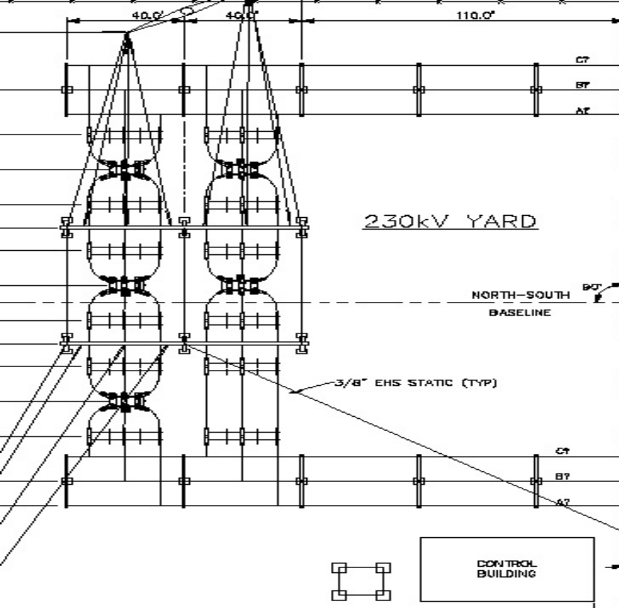
- Breaker and half

Question 3: Which one of the following component do not help in substation automation?
- Oil Circuit Breakers
Question 4: Which is the most commonly used communication protocol in IED’s in United States?
- DNP3.0
Question 5: Which of the following statements is correct?
- IEC 61850 is a superset of UCA 2.0
Question 6: The following one-line diagram shows the following switching configuration
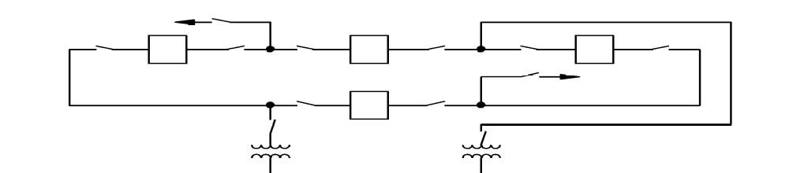
- Ring Bus
Question 7: Which of the following statement is correct?
- Both 1 and 3 are correct

Question 8: What does A and B represent in the following substation automation architecture?
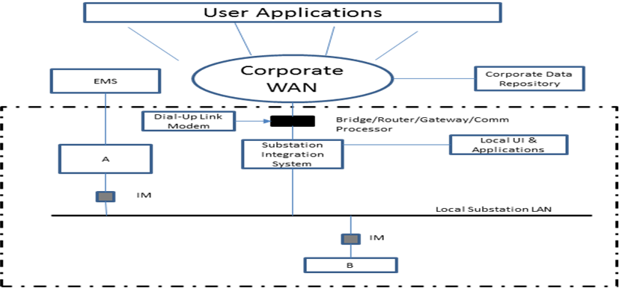
- A = Remote Terminal Unit; B = Intelligent Electronic Device
Question 9: Which one of the following never formed a part of substation communication media?
- 802.11
Question 10: Which of the following devices are the least vulnerable to cybersecurity attacks?
- Manual disconnect switches

